**Structure and Dynamic Memory Management assignments**

1.Refer the question 1 solved in “Structure and function”. Extend the above program to read a number of records from the user as a single command line argument (each record is delimited by a semicolon and record fields are delimited by comma) and store in an array of structures.

Sample input and output are given below.

Input: “user1,90;user21,100, userABC,56,userX,40”;

Output:

No. of records: 4

Record 1:

Name:user1, Percentage:90

Record 2:

Name:user21, Percentage:100

Record 3:

Name:userABC, Percentage:56

Record 4:

Name:userX, Percentage:40

Implement all required functions and call them to get the desired output.

Check for memory leak.

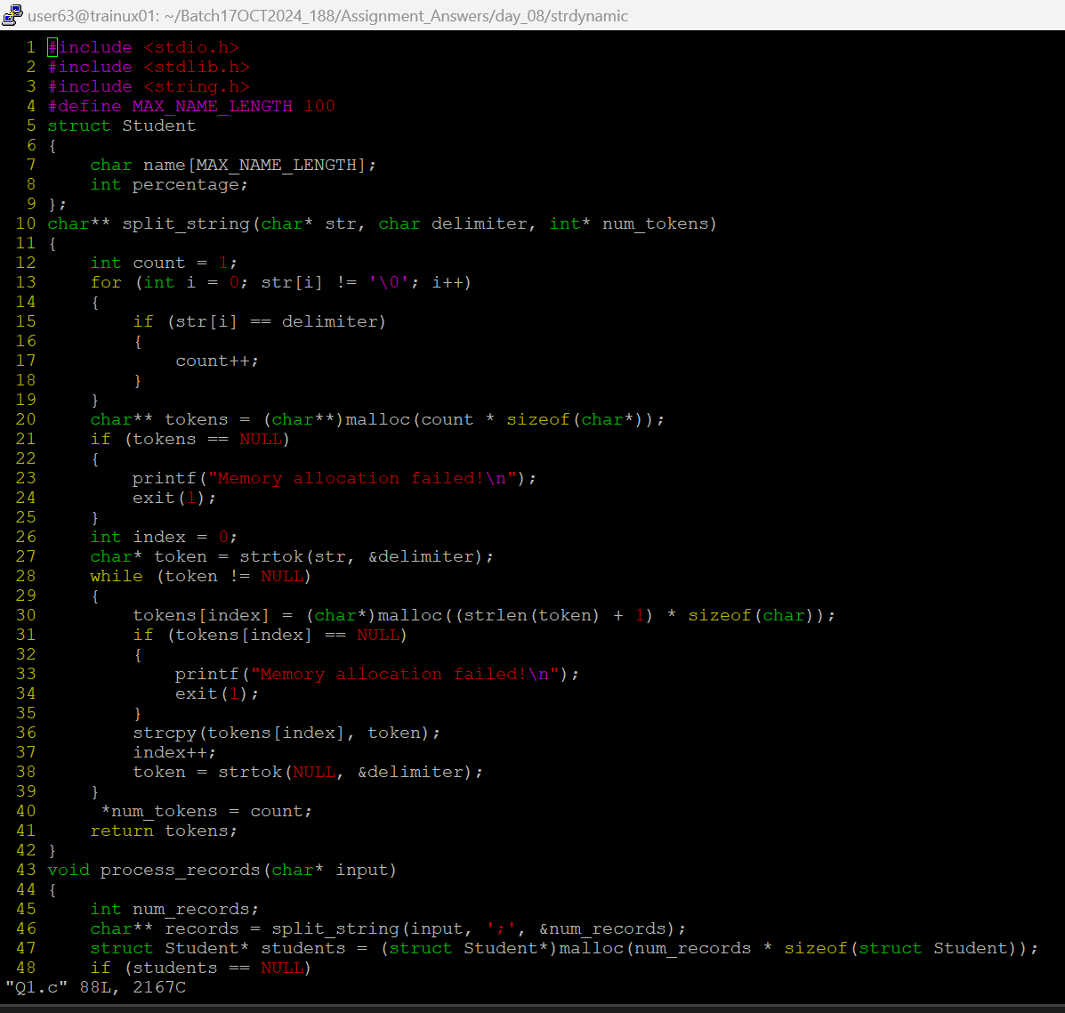

2a.Extend Q1. Above and add 3 functions below.

//to search for a name and to replace it with a user defined name, return replaced string

char*search_update(char *searchstr, char *replacestr);

//search and delete the record with given name or percentage value, return SUCCESS on successful delete else FAILURE

int delete_record(char *searchstr, int percent);

//search for name and if found create a copy of the record in newstudent

and return SUCCESS, else FAILURE

int copy(char *name, struct student **newstudent);

